**ASSIGNMENT-7**

**i.Display student names along with the department name.**

SELECT NAME , DEPTNAME FROM STUDENT2053, DEPARTMENT2053

WHERE STUDENT2053.DEPTCODE = DEPARTMENT2053.DEPTCODE;

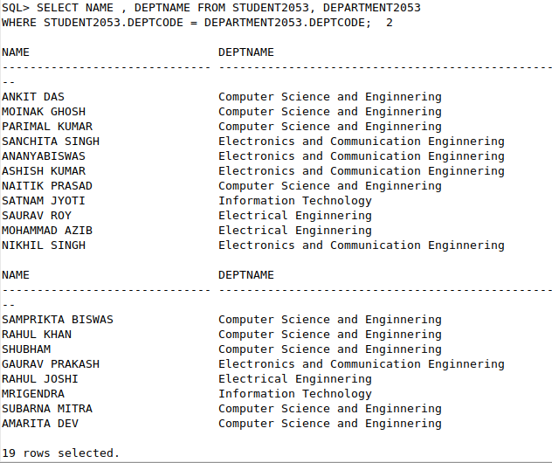

**ii.Display student names, subject code and marks of students who took admission in the year 2017 and read subject CS502.**

SELECT NAME, SUB_CODE, MARKS

FROM STUDENT2053 , RESULT2053

WHERE STUDENT2053.YEAROFADM=2017 AND STUDENT2053.ROLLNO = RESULT2053.ROLLNO AND RESULT2053.SUB_CODE='CS502';

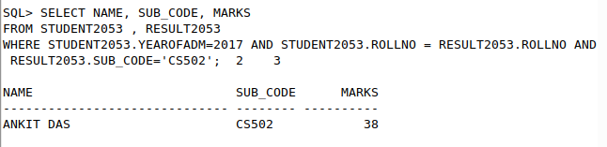

**iii.Find the name of the students who got marks between 70 to 89 in CS501.**

SELECT NAME

FROM STUDENT2053 , RESULT2053

WHERE RESULT2053.SUB_CODE='CS501' AND RESULT2053.ROLLNO=STUDENT2053.ROLLNO AND (RESULT2053.MARKS>=70 AND RESULT2053.MARKS <=89);

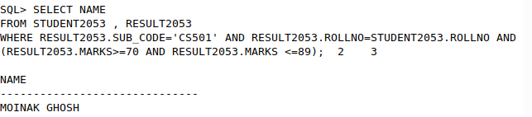

**iv.Find the student name, roll no who appeared in the examination for paper DBMS.**

SELECT NAME, STUDENT2053.ROLLNO

FROM STUDENT2053 , RESULT2053, SUBJECT2053

WHERE SUBJECT2053.SUBJECTNAME = 'Data Base Systems' AND SUBJECT2053.SUBJECTCODE=RESULT2053.SUB_CODE AND RESULT2053.ROLLNO=STUDENT2053.ROLLNO;

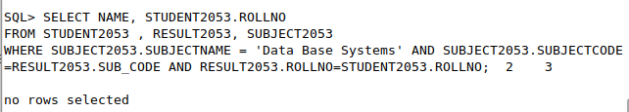

**v.Show student names, subject code and marks for CSE 3rdyear students.**

SELECT NAME, SUB_CODE , MARKS

FROM STUDENT2053, RESULT2053

WHERE STUDENT2053.SEMESTER='SEM5' AND STUDENT2053.DEPTCODE='CSE' AND STUDENT2053.ROLLNO=RESULT2053.ROLLNO;

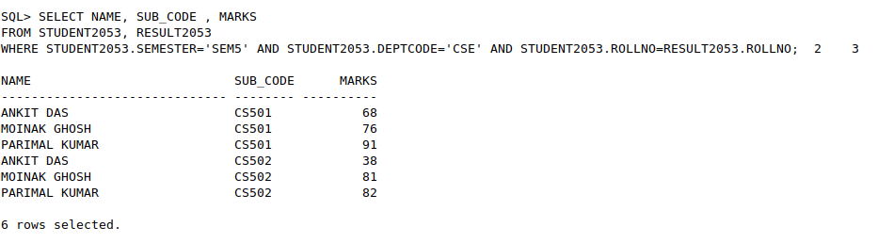

**vi.Show student names, department name for 5 th semester students who born in MAY.**

SELECT NAME , DEPTNAME

FROM DEPARTMENT2053, STUDENT2053

WHERE STUDENT2053.SEMESTER='SEM5' AND EXTRACT(MONTH FROM STUDENT2053.BITHDATE)=5 AND STUDENT2053.DEPTCODE=DEPARTMENT2053.DEPTCODE;

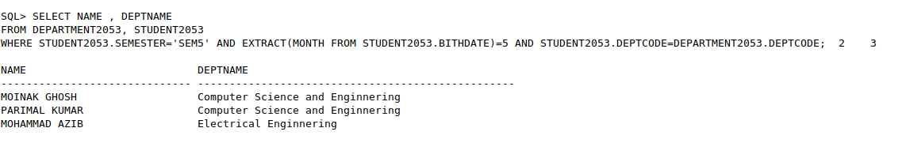

**vii.Show student names, subject name for 5thsemester student where subject name contains the word ‘DATA’**

SELECT NAME, SUBJECTNAME

FROM STUDENT2053, SUBJECT2053

WHERE STUDENT2053.SEMESTER='SEM5' AND SUBJECT2053.SUBJECTNAME LIKE '%Data%' AND STUDENT2053.DEPTCODE=SUBJECT2053.DEPTCODE AND STUDENT2053.SEMESTER=SUBJECT2053.SEMESTER;

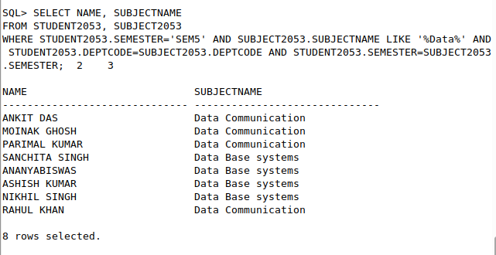

**viii.Show student names, subject name and marks for 5thsemester students.**

SELECT NAME, SUBJECTNAME, MARKS

FROM STUDENT2053, SUBJECT2053, RESULT2053

WHERE STUDENT2053.SEMESTER='SEM5' AND STUDENT2053.ROLLNO=RESULT2053.ROLLNO AND RESULT2053.SUB_CODE=SUBJECT2053.SUBJECTCODE;

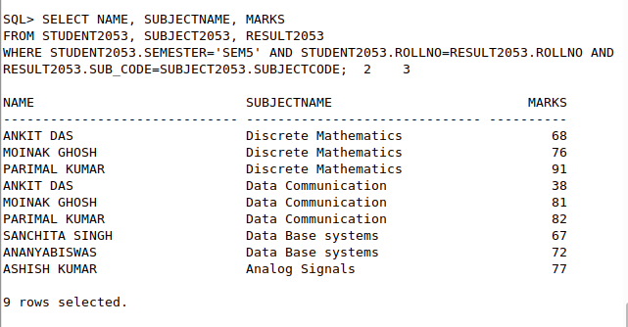

**ix.Find the roll number, student names and marks for CSE students who get more than 80 in Data Structure.**

SELECT STUDENT2053.ROLLNO, NAME, MARKS

FROM STUDENT2053, RESULT2053 , SUBJECT2053

WHERE STUDENT2053.DEPTCODE='CSE' AND MARKS > 80 AND STUDENT2053.ROLLNO=RESULT2053.ROLLNO AND SUBJECT2053.SUBJECTNAME='Data Structure' AND RESULT2053.SUB_CODE=SUBJECT2053.SUBJECTCODE;

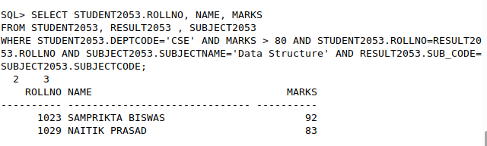

**x.Show student names, department name, subject name and subject wise marks for which the student get more than 90.**

SELECT NAME, DEPTNAME, SUBJECTNAME , MARKS

FROM STUDENT2053 , DEPARTMENT2053, SUBJECT2053, RESULT2053

WHERE MARKS > 90 AND STUDENT2053.ROLLNO = RESULT2053.ROLLNO AND STUDENT2053.DEPTCODE=DEPARTMENT2053.DEPTCODE AND RESULT2053.SUB_CODE=SUBJECT2053.SUBJECTCODE;

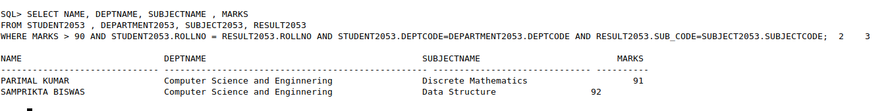

**xi.Add column HOD in DEPARTMENT. Insert faculty id in place of HoD.**

ALTER TABLE DEPARTMENT2053 ADD HOD VARCHAR2(4);

UPDATE DEPARTMENT2053 SET HOD = 'F01' WHERE DEPTCODE='CSE';

UPDATE DEPARTMENT2053 SET HOD = 'F02' WHERE DEPTCODE='ECE';

UPDATE DEPARTMENT2053 SET HOD = 'F03' WHERE DEPTCODE='IT';

UPDATE DEPARTMENT2053 SET HOD = 'F04' WHERE DEPTCODE='EE';

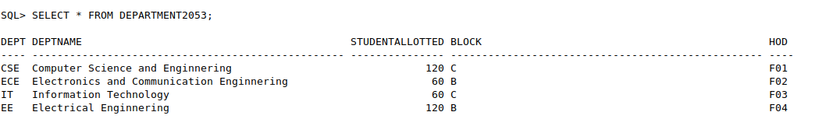

**xii.Add column TEACHER in table SUBJECT. Insert faculty id in this column.**

ALTER TABLE SUBJECT2053 ADD TEACHER VARCHAR2(4);

UPDATE SUBJECT2053 SET TEACHER = 'F01' WHERE SUBJECTCODE='CS301';

UPDATE SUBJECT2053 SET TEACHER = 'F02' WHERE SUBJECTCODE='CS302';

UPDATE SUBJECT2053 SET TEACHER = 'F03' WHERE SUBJECTCODE='CS501';

UPDATE SUBJECT2053 SET TEACHER = 'F04' WHERE SUBJECTCODE='CS502';

UPDATE SUBJECT2053 SET TEACHER = 'F05' WHERE SUBJECTCODE='ECS501';

UPDATE SUBJECT2053 SET TEACHER = 'F06' WHERE SUBJECTCODE='EC501';

UPDATE SUBJECT2053 SET TEACHER = 'F07' WHERE SUBJECTCODE='CS503';

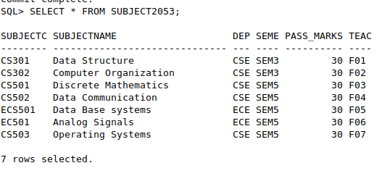

**xiii.Show the department name, semester, subject name along with faculty name.**

SELECT DEPTNAME, SEMESTER, SUBJECTNAME, NAME

FROM SUBJECT2053 ,DEPARTMENT2053, FACULTY2053

WHERE SUBJECT2053.DEPTCODE=DEPARTMENT2053.DEPTCODE AND SUBJECT2053.TEACHER=FACULTY2053.FID;

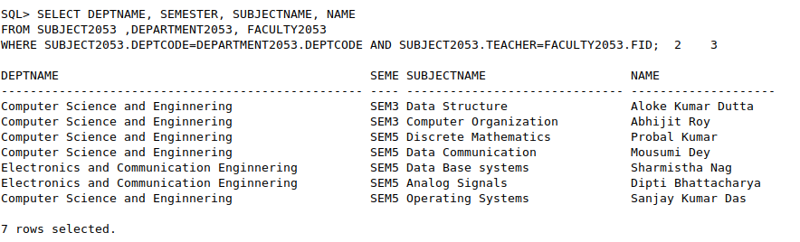

**xiv.Find the names of all faculties whose HOD name is given.**

SELECT NAME , DEPARTMENT2053.DEPTNAME

FROM FACULTY2053, DEPARTMENT2053

WHERE FACULTY2053.FID = DEPARTMENT2053.HOD;

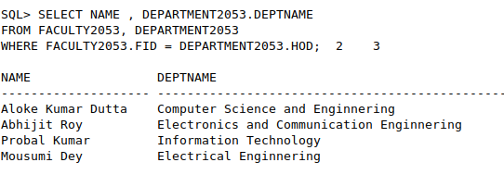

**xv.Display subject name, subject code, marks including all subjects. [Outer join ]**

SELECT SUBJECT2053.SUBJECTNAME, SUBJECT2053.SUBJECTCODE, RESULT2053.MARKS

FROM SUBJECT2053

LEFT OUTER JOIN RESULT2053

ON SUBJECT2053.SUBJECTCODE=RESULT2053.SUB_CODE;

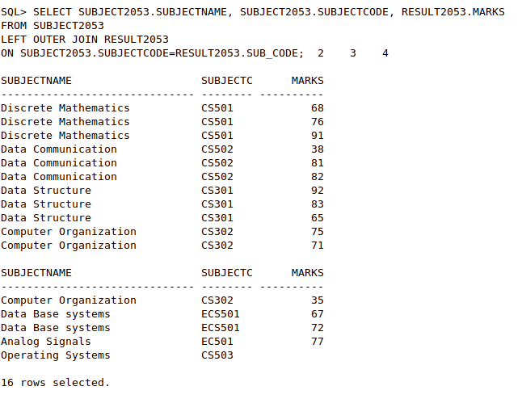

**xvi.Display students name, subject code, marks. Include all students. [Outer join ]**

SELECT STUDENT2053.NAME, RESULT2053.SUB_CODE, RESULT2053.MARKS

FROM STUDENT2053

LEFT OUTER JOIN RESULT2053

ON STUDENT2053.ROLLNO=RESULT2053.ROLLNO;

